PROFORMA INVOICE

Quotation no: B&F PI-302
Date 08/11/2024

To,

B&F Realty-Villa 3
Goa

Dear Sir,
Kindly find the quotation as per your requirement.

ENDO

PROJECT : RIVER GLADE VILLAS |  |  |  |  | BILL OF QUANTITIES FOR RIVER GLADE VILLAS - Villa 03 |  |  |  | Date: 24 SEPT 2024 |  |  |  |  |  |  |  |  | DATE: 07 NOV 2024
Notes : Included are luminaires suggested for - Interior Lighting for VILLA-03
Kindly Refer the detail specifications with this BOQ. If you Find any descripancies , please get it to our notice before placing final order.
 |  |  |  |  |  |  |  |  |  |  |  |  |  |  |  |  |  | ENDO ALTERNATES
Sr No | Specification Description |  |  |  |  | Symbol |  | Manufacturer |  | Total Quantity |  | Remarks |  |  |  |  |  | Sr No | Specification Description |  | Symbol |  | Manufacturer |  | Total Quantity |  | Remarks/ L@W Comments |  | BEST PRICE |  | Total
1 | LED Strip Light with flat Channel & Clear Cover. |  |  |  |  |  |  | OSRAM LIGHTING |  |  |  |  |  |  |  |  |  | 1 | LED Strip Light with flat Channel & Clear Cover. |  |  |  | ENDO LIGHTING
 | Housing: Extruded aluminium Channel & clear Cover. |  |  |  |  | COV1 |  | LFP 1200S-G5-930-10 L1 |  | 57.50 |  | The actual Lengths required to be confirmed as per site. |  |  |  |  |  |  | Housing: Extruded aluminium Channel & clear Cover. |  | COV1 |  | TSUKI-R-1714-10W/Mtr |  | 57.50 |  | SUGGEST IN 10W/Mt.  The actual Lengths required to be confirmed as per site., OLD QTY 55 MTR |  | 1172 |  | 67390
 | Dimension: 17.1 X 8mm |  |  |  |  |  |  | 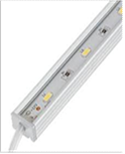 |  | Mtrs. |  |  |  |  |  |  |  |  | Dimension: 17 X 14mm |  |  |  | 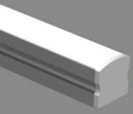 |  | Mtrs.
 | Accessory: DG-A002 with Clear Cover |  |  |  |  |  |  |  |  |  |  |  |  |  |  |  |  |  | Accessory: Channel & Clear Cover.
 | Lamp: 11.6W/Mt, 3000K, CRI=90+ |  |  |  |  |  |  |  |  |  |  |  |  |  |  |  |  |  | Lamp: 15W/Mt, 3000K, CRI=90+
 | Lumen Output :1100lm/Mt |  |  |  |  |  |  |  |  |  |  |  |  |  |  |  |  |  | Lumen Output :1500lm/Mt
 | Control Gear: Remote LED Driver. Dali Dimmable. |  |  |  |  |  |  |  |  |  |  |  |  |  |  |  |  |  | Control Gear: Remote LED Driver. Dali Dimmable.
 | Power Consumption: 11.6W/Mt |  |  |  |  |  |  |  |  |  |  |  |  |  |  |  |  |  | Power Consumption: 10W/Mt
 | IP20 |  |  |  |  |  |  |  |  |  |  |  |  |  |  |  |  |  | IP20
 |  |  |  |  |  |  |  |  |  |  |  |  |  |  |  |  |  |  |  |  |  |  | 80W, 24V Dali Driver |  | 12.00 |  |  |  | 4992 |  | 59904
2 | LED Strip Light along circular cove. |  |  |  |  |  |  | OSRAM LIGHTING |  |  |  |  |  |  |  |  |  | 2 | LED Strip Light along circular cove. |  |  |  | ENDO LIGHTING |  |  |  |  |  | 4425 |  | 61950
 | Housing: 24 V LED strips flexible and cuttable, 50 mm cut unit, with superior optically graded silicone encapsulation. |  |  |  |  | COV1c |  | GFDS600-G1-830-01 |  | 14.00 |  | The actual Length required in Circular cove, to be confirmed as per Site. |  |  |  |  |  |  | Housing: Silicone |  | COV1c |  | TSUKI-NF-DB-16X16-NS-130- 14W-IP67 |  | 14.00 |  | OK.  The actual Length required in Circular cove, to be confirmed as per Site.
 | Dimension: 10 X 10mm |  |  |  |  |  |  | 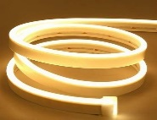 |  | Mtrs. |  |  |  |  |  |  |  |  | Dimension: 16 X 16mm |  |  |  |  |  | Mtrs.
 | Accessory: Fixing clips |  |  |  |  |  |  |  |  |  |  |  |  |  |  |  |  |  | Accessory: Fixing Clips
 | Lamp: 9W/Mt LED, 110º 3000K, CRI=90+ |  |  |  |  |  |  |  |  |  |  |  |  |  |  |  |  |  | Lamp: 14W/Mt LED, 120° 3000K, CRI=85+
 | Lumen Output : 620lm/Mt |  |  |  |  |  |  |  |  |  |  |  |  |  |  |  |  |  | Lumen Output : 710lm/Mt
 | Control Gear: Remote LED Driver. Dali Dimmable. |  |  |  |  |  |  |  |  |  |  |  |  |  |  |  |  |  | Control Gear: Remote LED Driver. Dali Dimmable.
 | Power Consumption: 9W/Mt |  |  |  |  |  |  |  |  |  |  |  |  |  |  |  |  |  | Power Consumption: 14W/Mt
 | IP20 |  |  |  |  |  |  |  |  |  |  |  |  |  |  |  |  |  | IP67
 |  |  |  |  |  |  |  |  |  |  |  |  |  |  |  |  |  |  |  |  |  |  | 80W, 24V Dali Driver |  | 3.00 |  |  |  | 4992 |  | 14976
 |  |  |  |  |  |  |  |  |  |  |  |  |  |  |  |  |  |  |  |  |  |  |  |  | Nos
3 | LED Strip light with 45° Channel & Diffuse Cover. |  |  |  |  |  |  | OSRAM LIGHTING |  |  |  |  |  |  |  |  |  | 3 | LED Strip light with 45° Channel & Diffuse Cover. |  |  |  | ENDO LIGHTING |  |  |  |  |  | 1319 |  | 137836
 | Housing: Extruded aluminium Channel & 45° Cover |  |  |  |  | COV2 |  | LFP800S -G5-930-10 L1 |  | 104.50 |  | Mounted in wardrobes & Curtain pelmets.  Actual lengths to be confirmed as per site. |  |  |  |  |  |  | Housing: Extruded aluminium 45° Channel & Diffuse Cover |  | COV2 |  | TSUKI-R-1818-10W/Mtr |  | 104.50 |  | OK.  Mounted in wardrobes & Curtain pelmets.  Actual lengths to be confirmed as per site. OLD QTY 88 MTR
 | Dimension: 16 X 16mm |  |  |  |  |  |  | 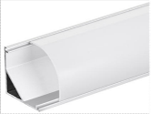 |  | Mtrs. |  |  |  |  |  |  |  |  | Dimension: 18 X18mm |  |  |  | 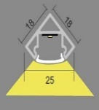 |  | Mtrs.
 | Accessory: DG-A008 with Diffuse Cover |  |  |  |  |  |  |  |  |  |  |  |  |  |  |  |  |  | Accessory: 45° Channel with Diffuse Cover
 | Lamp: 8W/Mt LED, 3000K, CRI=90+ |  |  |  |  |  |  |  |  |  |  |  |  |  |  |  |  |  | Lamp: 10W/Mt LED, 3000K, CRI=90+
 | Lumen Output : 840 lm/Mt |  |  |  |  |  |  |  |  |  |  |  |  |  |  |  |  |  | Lumen Output : 1000lm/Mt
 | Control Gear: Remote LED Driver. Dali Dimmable. |  |  |  |  |  |  |  |  |  |  |  |  |  |  |  |  |  | Control Gear: Remote LED Driver. Dali Dimmable.
 | Power Consumption: 8W/Mt |  |  |  |  |  |  |  |  |  |  |  |  |  |  |  |  |  | Power Consumption: 10W/Mt
 | IP20 |  |  |  |  |  |  |  |  |  |  |  |  |  |  |  |  |  | IP20
 |  |  |  |  |  |  |  |  |  |  |  |  |  |  |  |  |  |  |  |  |  |  | 80W, 24V Dali Driver |  | 21.00 |  |  |  | 4992 |  | 104832
4 | LED Strip Light with Flat Channel & Dotless Diffuse Cover |  |  |  |  |  |  | OSRAM LIGHTING |  |  |  |  |  |  |  |  |  | 4 | LED Strip Light with Flat Channel & Dotless Diffuse Cover |  |  |  | ENDO LIGHTING |  |  |  |  |  | 1172 |  | 79110
 | Housing: Extruded aluminium Channel & Diffuse Cover |  |  |  |  | COV3 |  | LFP800S -G5-930-10 L1 |  | 67.50 |  | For task Lighting in Kitchen.  Actual lengths to be confirmed as per Site. |  |  |  |  |  |  | Housing: Extruded aluminium Channel & Diffuse Cover |  | COV3 |  | TSUKI-R-1714-10W/Mtr |  | 67.50 |  | OK.  For task Lighting in Kitchen.  Actual lengths to be confirmed as per Site., OLD QTY 62 MTR
 | Dimension:17.1mm X 8mm |  |  |  |  |  |  | 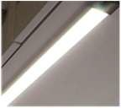 |  | Mtrs. |  |  |  |  |  |  |  |  | Dimension: 17 X 14mm |  |  |  | 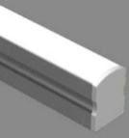 |  | Mtrs.
 | Accessory: DG-A002 with Diffuse Cover |  |  |  |  |  |  |  |  |  |  |  |  |  |  |  |  |  | Accessory: Channel with Diffuse Cover
 | Lamp: 8W/Mt LED, 3000K, CRI=90+ |  |  |  |  |  |  |  |  |  |  |  |  |  |  |  |  |  | Lamp: 10W/Mt LED, 3000K, CRI=90+
 | Lumen Output :840lm/Mt |  |  |  |  |  |  |  |  |  |  |  |  |  |  |  |  |  | Lumen Output :100lm/Mt
 | Control Gear: Remote LED Driver. Dali Dimmable. |  |  |  |  |  |  |  |  |  |  |  |  |  |  |  |  |  | Control Gear: Remote LED Driver. Dali Dimmable.
 | Power Consumption: 8W/Mt |  |  |  |  |  |  |  |  |  |  |  |  |  |  |  |  |  | Power Consumption: 10W/Mt
 | IP65 |  |  |  |  |  |  |  |  |  |  |  |  |  |  |  |  |  | IP20
 |  |  |  |  |  |  |  |  |  |  |  |  |  |  |  |  |  |  |  |  |  |  | 80W, 24V Dali Driver |  | 14.00 |  |  |  | 4992 |  | 69888
5 | LED Strip Light with Channel & Dotless Diffuse Cover |  |  |  |  |  |  | OSRAM LIGHTING |  |  |  |  |  |  |  |  |  | 5 | LED Strip Light with Channel & Dotless Diffuse Cover |  |  |  | ENDO LIGHTING |  |  |  |  |  | 1251 |  | 160754
 | Housing: Extruded aluminium Channel & Diffuse Cover |  |  |  |  | COV4 |  | LF500-G1-930-10 L2 |  | 128.50 |  | Actual Length to be confirmed as per site. |  |  |  |  |  |  | Housing: Extruded aluminium Channel & Cover |  | COV4 |  | TSUKI-S-1714-5W/Mtr (IP65) |  | 128.50 |  | IP65 Required  Actual Length to be confirmed as per site., OLD QTY 125 MTR & IP20
 | Dimension: 17.1mm X 8mm |  |  |  |  |  |  | 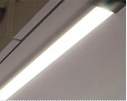 |  | Mtrs. |  |  |  |  |  |  |  |  | Dimension: 17mm X 14mm |  |  |  | 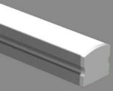 |  | Mtrs.
 | Accessory: DG-A010 with Diffuse Cover |  |  |  |  |  |  |  |  |  |  |  |  |  |  |  |  |  | Accessory: Channel with Diffuse Cover
 | Lamp: 3.9W/Mt LED, 3000K, CRI=90+ |  |  |  |  |  |  |  |  |  |  |  |  |  |  |  |  |  | Lamp: 5W/Mt LED, 3000K, CRI=90+
 | Lumen Output : 400lm/Mt |  |  |  |  |  |  |  |  |  |  |  |  |  |  |  |  |  | Lumen Output : 500lm/Mt
 | Control Gear: Remote LED Driver. Dali Dimmable. |  |  |  |  |  |  |  |  |  |  |  |  |  |  |  |  |  | Control Gear: Remote LED Driver. Dali Dimmable.
 | Power Consumption: 3.9W |  |  |  |  |  |  |  |  |  |  |  |  |  |  |  |  |  | Power Consumption: 5W
 | IP65 |  |  |  |  |  |  |  |  |  |  |  |  |  |  |  |  |  | IP65
 |  |  |  |  |  |  |  |  |  |  |  |  |  |  |  |  |  |  |  |  |  |  | 80W, 24V Dali Driver |  | 14.00 |  |  |  | 4992 |  | 69888
6 | Flex Light with Top View |  |  |  |  |  |  | OSRAM LIGHTING |  |  |  |  |  |  |  |  |  | 6 | Flex Light with Top View |  |  |  | ENDO LIGHTING |  |  |  |  |  | 4425 |  | 40710
 | Housing: Silicone |  |  |  |  | FLX1 |  | GFDT400-G1-830-01 |  | 9.20 |  | Actual Length to be confirmed as per site. |  |  |  |  |  |  | Housing: Silicone |  | FLX1 |  | TSUKI-NF-DB-16X16-NS-130- 9W-IP67 |  | 9.20 |  | 14W/Mt is too high, (5W/Mt to 7W/Mt LED required)  Actual Length to be confirmed as per site., OLD QTY 3.15 MTR
 | Dimension: 10mm X 10mm |  |  |  |  |  |  | 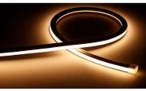 |  | Mtrs. |  |  |  |  |  |  |  |  | Dimension: 16 X 16mm |  |  |  |  |  | Mtrs.
 | Accessory: Mounting Clips. |  |  |  |  |  |  |  |  |  |  |  |  |  |  |  |  |  | Accessory: Fixing Clips |  |  |  | 
 | Lamp: 6W/Mts LED ,110° CRI=90+ |  |  |  |  |  |  |  |  |  |  |  |  |  |  |  |  |  | Lamp: 9W/Mt LED, 120° 3000K, CRI=85+
 | Lumen Output : 420lm/Mts |  |  |  |  |  |  |  |  |  |  |  |  |  |  |  |  |  | Lumen Output : 710lm/Mt
 | Control Gear: Remote LED Driver. Dali Dimmable. |  |  |  |  |  |  |  |  |  |  |  |  |  |  |  |  |  | Control Gear: Remote LED Driver. Dali Dimmable.
 | Power Consumption: 6W/Mts |  |  |  |  |  |  |  |  |  |  |  |  |  |  |  |  |  | Power Consumption: 9W/Mt
 | IP65 |  |  |  |  |  |  |  |  |  |  |  |  |  |  |  |  |  | IP67
 |  |  |  |  |  |  |  |  |  |  |  |  |  |  |  |  |  |  |  |  |  |  | 80W, 24V Dali Driver |  | 2.00 |  |  |  | 4992 |  | 9984
 |  |  |  |  |  |  |  |  |  |  |  |  |  |  |  |  |  |  |  |  |  |  |  |  |  |  | OLD QTY 32 NOS |  | 9045 |  | 298485
7 | Ceiling Recessed LED Down Light (IP Rated) |  |  |  |  |  |  | ENDO LIGHTING |  |  |  |  |  |  |  |  |  | 7 | Ceiling Recessed LED Down Light (IP Rated) |  |  |  | ENDO LIGHTING
 | Housing: Die cast Aluminium |  |  |  |  | IPR1 |  | GERD8901W-T |  | 33.00 |  |  |  |  |  |  |  |  | Housing: Die cast Aluminium |  | IPR1 |  | GERD8901W-T |  | 33.00
 | Dimension:Trim∅=60mm, Ht=95mm |  |  |  |  | White Trim |  | 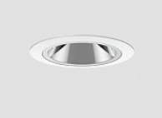 |  | Nos |  |  |  |  |  |  |  |  | Dimension:Trim∅=60mm, Ht=95mm |  | White Trim |  |  |  | Nos
 | Lamp:10.2W LED, 22° Fixed,3000K, CRI=90+(R9≥40+) |  |  |  |  |  |  |  |  |  |  |  |  |  |  |  |  |  | Lamp: 10.2W LED, 23° Fixed,3000K, CRI=90+(R9≥40+)
 | Lumen Output : 446lm |  |  |  |  |  |  |  |  |  |  |  |  |  |  |  |  |  | Lumen Output : 446lm
 | Control Gear: Remote LED Driver. Dali Dimmable. |  |  |  |  |  |  |  |  |  |  |  |  |  |  |  |  |  | Control Gear: Remote LED Driver. Dali Dimmable.
 | Power Consumption: 10.2W |  |  |  |  |  |  |  |  |  |  |  |  |  |  |  |  |  | Power Consumption: 10.2W
 | IP44 |  |  |  |  |  |  |  |  |  |  |  |  |  |  |  |  |  | IP44
8 | In-ground LED Up lighter. |  |  |  |  |  |  | PUK LIGHTING |  |  |  |  |  |  |  |  |  | 8 | In-ground LED Up lighter. |  |  |  |  |  |  |  |  |  | 9317 |  | 139755
 | Housing: Aluminium Body & Stainless Steel Trim |  |  |  |  | IUL1 |  | 201073 |  | 15.00 |  |  |  |  |  |  |  |  |  |  | IUL1 |  | ELUIR1-70-0630-KN |  | 15.00 |  | Share the data sheet of this.
 | Dimension: Trim∅=81mm, & Ht=85mm |  |  |  |  |  |  | 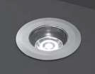 |  | Nos |  |  |  |  |  |  |  |  | ELUIR1-70-0630-KN  (Tsuki ingorund 5.8W, 9Deg, 3000K, 80 CRI, 70mm Dia, Non Dimmable ) |  |  |  | 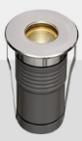 |  | Nos
 | Lamp: 5W LED, 10°, 3000K CRI=80+
 | Lumen Output : 489lm
 | Control Gear: Remote LED Driver. Non-Dimmable.
 | Power Consumption: 5W
 | IP68
9 | Profile System , Recessed Magnetic Track. |  |  |  |  |  |  | DELTA LIGHTING |  |  |  | Drawing to be shared with Vendor to finalize unit modules & connectors. |  |  |  |  |  | 9 | Profile System , Recessed Magnetic Track. |  |  |  |  |  |  |  |  |  | 5842 |  | 70104
 | Housing: Anodised Aluminum |  |  |  |  | PSY1 |  | Splitline M20 |  | 12.00 |  |  |  |  |  |  |  |  | XR-CMT410 (48V DC Recess track with all accesoried) |  | PSY1 |  | Track |  | 12.00 |  | A recessed track with  trim preferred.  Share the data sheet of this.  Drawing to be shared with Vendor to finalize unit modules & connectors.
 | Dimensionin Section : W=53mm, D=50mm |  |  |  |  |  |  | 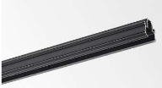 |  | Mtrs. |  |  |  |  |  |  |  |  |  |  |  |  | 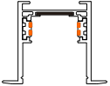 |  | Nos
 | Accessory: Connector Sets - As per Vendor. |  |  |  |  |  |  |  |  | LEngth
 | Control Gear: Remote LED Driver. Dali Dimmable.
 | IP20
9a | Recessed Linear LED light in Profile System. |  |  |  |  |  |  | DELTA LIGHTING |  |  |  |  |  |  |  |  |  | 9a | Recessed Linear LED light in Profile System. |  |  |  | ENDO LIGHTING |  |  |  |  |  | 12491 |  | 112419
 | Housing: Anodised Aluminum |  |  |  |  | M1 |  | LND-06-SP-30F-B-M-MDL (23303 9000) |  | 8.00 |  |  |  |  |  |  |  |  | Housing: Aluminum + PC |  | M1 |  | FL-24G |  | 9.00 |  | Quantity will change since length is lesser. Refer the shared render given by I.D.  Share the IES file to evaluate.
 | Dimension: L=621mm W=20mm, D=50mm |  |  |  |  |  |  |  |  | Nos |  |  |  |  |  |  |  |  | Dimension: L=485mm W=25mm, D=46mm |  |  |  |  |  | Nos
 | Accessory: SplitLine M20 - Profile |  |  |  |  |  |  | 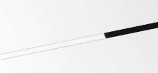 |  |  |  |  |  |  |  |  |  |  | Accessory: Recessing Track - Profile |  |  |  | 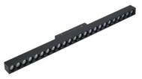
 | Lamp: 9.1W/621mm LED, 3000K, CRI=90+(R9≥40+) |  |  |  |  |  |  |  |  |  |  |  |  |  |  |  |  |  | Lamp: 24W/485mm LED, 3000K, CRI=90+(R9≥40+)
 | Lumen Output : 625lm/621mm |  |  |  |  |  |  |  |  |  |  |  |  |  |  |  |  |  | Lumen Output : 1000lm/300mm
 | Control Gear: Remote LED Driver. Dali Dimmable. |  |  |  |  |  |  |  |  |  |  |  |  |  |  |  |  |  | Control Gear: Remote LED Driver. Dali Dimmable.
 | Power Consumption: 9.1W |  |  |  |  |  |  |  |  |  |  |  |  |  |  |  |  |  | Power Consumption:24W/485mm
 | IP20 |  |  |  |  |  |  |  |  |  |  |  |  |  |  |  |  |  | IP20
9b | Recessed LED Twin Spot light in Profile System. |  |  |  |  |  |  | DELTA LIGHTING |  |  |  |  |  |  |  |  |  | 9b | Recessed LED Twin Spot light in Profile System. |  |  |  | ENDO LIGHTING |  |  |  |  |  | 14514 |  | 174168
 | Housing: Anodised Aluminum |  |  |  |  | M2 |  | B (233179320) |  | 12.00 |  |  |  |  |  |  |  |  | Housing: Aluminum |  | M2 |  | GERS7013BA-T(Mini 40 spot) |  | 12.00 |  | Quantity will change. Refer the shared render given by I.D.  Share the IES file to evaluate.
 | Dimension: TrimØ=39mm, L=170mm H=116mm |  |  |  |  |  |  |  |  | Nos |  |  |  |  |  |  |  |  | Dimension: TrimØ=45mm, L=94mm & Ht=52mm |  |  |  |  |  | Nos
 | Accessory: SplitLine M20 - Profile |  |  |  |  |  |  |  |  |  |  |  |  |  |  |  |  |  | Accessory: Recessing Track - Profile
 | Lamp: 2X8.5W LED, 3000K, CRI=90+(R9≥40+) |  |  |  |  | 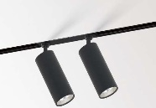 |  |  |  |  |  |  |  |  |  |  |  |  | Lamp: 10.2W LED 33°, 3000K, CRI=83+(R9≥40+) |  | 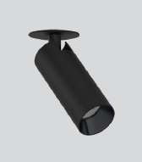
 | Lumen Output : 1089lm |  |  |  |  |  |  |  |  |  |  |  |  |  |  |  |  |  | Lumen Output : 767lm
 | Control Gear: Remote LED Driver. Dali Dimmable. |  |  |  |  |  |  |  |  |  |  |  |  |  |  |  |  |  | Control Gear: Remote LED Driver. Dali Dimmable.
 | Power Consumption: 2X8.5W |  |  |  |  |  |  |  |  |  |  |  |  |  |  |  |  |  | Power Consumption: 10.2W
 | IP20 |  |  |  |  |  |  |  |  |  |  |  |  |  |  |  |  |  | IP20
10 | Ceiling Recessed LED Pin Spot Down Light. |  |  |  |  |  |  | ENDO LIGHTING |  |  |  |  |  |  |  |  |  | 10 | Ceiling Recessed LED Pin Spot Down Light. |  |  |  | GERD9898W-T |  |  |  |  |  | 5686 |  | 28430
 | Housing: Die cast aluminium |  |  |  |  | PNS1 |  | GERD9898W-T |  | 5.00 |  |  |  |  |  |  |  |  | Housing: Die cast aluminium |  | PNS1 |  | 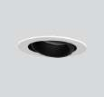 |  | 5.00 |  | The alternate is missing in received BOQ, NEW ITEM
 | Dimension: Trim∅=37mm, CutOut∅=35mm Ht=42mm. |  |  |  |  |  |  |  |  | Nos |  |  |  |  |  |  |  |  | Dimension: Trim∅=37mm, CutOut∅=35mm Ht=42mm. |  |  |  |  |  | Nos
 | Lamp: 3.1W LED 29°, Focusable, 3000K, CRI=93+(R9≥40+) |  |  |  |  |  |  |  |  |  |  |  |  |  |  |  |  |  | Lamp: 3.1W LED 29°, Focusable, 3000K, CRI=93+(R9≥40+)
 | Lumen Output: 178lm |  |  |  |  |  |  |  |  |  |  |  |  |  |  |  |  |  | Lumen Output: 178lm
 | Control Gear: Remote LED Driver. Dali Dimmable. |  |  |  |  |  |  |  |  |  |  |  |  |  |  |  |  |  | Control Gear: Remote LED Driver. Dali Dimmable.
 | Power Cosumption: 3.1W |  |  |  |  |  |  |  |  |  |  |  |  |  |  |  |  |  | Power Cosumption: 3.1W
 | IP20 |  |  |  |  |  |  |  |  |  |  |  |  |  |  |  |  |  | IP20
11 | Ceiling Recessed LED Pin Spot Down Light. |  |  |  |  |  |  | ENDO LIGHTING |  |  |  |  |  |  |  |  |  | 11 | Ceiling Recessed LED Pin Spot Down Light. |  |  |  |  |  |  |  |  |  | 10552 |  | 84416
 | Housing: Die cast aluminium |  |  |  |  | PNS2 |  | GERD9869W-T |  | 8.00 |  |  |  |  |  |  |  |  | Housing: Die cast aluminium |  | PNS2 |  | GERD9869W-T |  | 8.00 |  | The alternate is missing in received BOQ, NEW ITEM
 | Dimension: Trim∅=60mm,Cut Out∅=50mm Ht=101mm. |  |  |  |  |  |  | 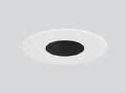 |  | Nos |  |  |  |  |  |  |  |  | Dimension: Trim∅=60mm,Cut Out∅=50mm Ht=101mm. |  |  |  |  |  | Nos
 | Lamp: 10.3W LED 21°, Focusable, 3000K, CRI=93+(R9≥40+) |  |  |  |  |  |  |  |  |  |  |  |  |  |  |  |  |  | Lamp: 10.3W LED 21°, Focusable, 3000K, CRI=93+(R9≥40+)
 | Lumen Output: 446lm |  |  |  |  |  |  |  |  |  |  |  |  |  |  |  |  |  | Lumen Output: 446lm
 | Control Gear: Remote LED Driver. Dali Dimmable. |  |  |  |  |  |  |  |  |  |  |  |  |  |  |  |  |  | Control Gear: Remote LED Driver. Dali Dimmable.
 | Power Cosumption: 10.3W |  |  |  |  |  |  |  |  |  |  |  |  |  |  |  |  |  | Power Cosumption: 10.3W
 | IP20 |  |  |  |  |  |  |  |  |  |  |  |  |  |  |  |  |  | IP20
12 | Ceiling Recessed LED Down Light. |  |  |  |  |  |  | ENDO LIGHTING |  |  |  |  |  |  |  |  |  | 12 | Ceiling Recessed LED Down Light. |  |  |  | ENDO LIGHTING |  |  |  |  |  | 9621 |  | 355977
 | Housing: Die cast aluminium |  |  |  |  | RDN1 |  | GERD8280WB-T |  | 37.00 |  |  |  |  |  |  |  |  | Housing: Aluminium |  | RDN1 |  | GSTDA1800W-AMH30 |  | 37.00 |  | Kindly Suggest ACCORD (2000 TYPE -  19.6W Middle Beam Angle), OLD QTY 32 NOS
 | Dimension:∅=85mm, H=135mm. |  |  |  |  |  |  | 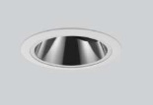 |  | Nos |  |  |  |  |  |  |  |  | Dimension:∅=65mm, H=129mm. |  |  |  | 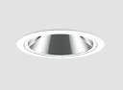 |  | Nos
 | Lamp: 19.6W LED 20°, Focusable, 3000K, CRI=93+(R9≥40+) |  |  |  |  |  |  |  |  |  |  |  |  |  |  |  |  |  | Lamp: 19.8W LED 23°, Focusable, 3000K, CRI=93+(R9≥40+)
 | Lumen Output: 807lm |  |  |  |  |  |  |  |  |  |  |  |  |  |  |  |  |  | Lumen Output: 1243lm
 | Control Gear: Remote LED Driver. Dali Dimmable. |  |  |  |  |  |  |  |  |  |  |  |  |  |  |  |  |  | Control Gear: Remote LED Driver. Dali Dimmable.
 | Power Cosumption: 19.8W |  |  |  |  |  |  |  |  |  |  |  |  |  |  |  |  |  | Power Cosumption: 19.8W
 | IP20 |  |  |  |  |  |  |  |  |  |  |  |  |  |  |  |  |  | IP20
13 | Ceiling Reccesed LED Down Light. |  |  |  |  |  |  | ENDO Lighting |  |  |  |  |  |  |  |  |  | 13 | Ceiling Reccesed LED Down Light. |  |  |  | ENDO LIGHTING |  |  |  |  |  | 9621 |  | 221283
 | Housing: Die cast aluminium |  |  |  |  | RDN2 |  | GERD8282WB-T |  | 23.00 |  |  |  |  |  |  |  |  | Housing: Aluminium |  | RDN2 |  | GSTDA1800W-AWH30 |  | 23.00 |  | Kindly Suggest ACCORD (2000 TYPE -  19.6W Wide Beam Angle), OLD QTY 32 NOS
 | Dimension:L=∅=85mm, H=135mm. |  |  |  |  |  |  | 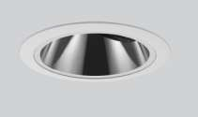 |  | Nos |  |  |  |  |  |  |  |  | Dimension:L=∅=65mm, H=129m. |  |  |  | 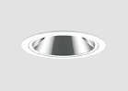 |  | Nos
 | Lamp: 19.6W LED 33°, Focusable, 3000K, CRI=93+(R9≥40+) |  |  |  |  |  |  |  |  |  |  |  |  |  |  |  |  |  | Lamp: 19.8W LED 33°, Focusable, 3000K, CRI=93+(R9≥40+)
 | Lumen Output : 1116lm |  |  |  |  |  |  |  |  |  |  |  |  |  |  |  |  |  | Lumen Output: 1368lm
 | Control Gear: Remote LED Driver. Dali Dimmable. |  |  |  |  |  |  |  |  |  |  |  |  |  |  |  |  |  | Control Gear: Remote LED Driver. Dali Dimmable.
 | Power Consumption: 19.8W |  |  |  |  |  |  |  |  |  |  |  |  |  |  |  |  |  | Power Cosumption: 19.8W
 | IP20 |  |  |  |  |  |  |  |  |  |  |  |  |  |  |  |  |  | IP20
14 | Ceiling Reccesed LED Twin Down Light.(Black Trim Required) |  |  |  |  |  |  | ENDO Lighting |  |  |  |  |  |  |  |  |  | 14 | Ceiling Reccesed LED Twin Down Light.  (Black Trim Required) |  |  |  |  |  |  |  |  |  | 17792 |  | 569344
 | Housing: Die cast aluminium |  |  |  |  | RDN3 |  | GERD8849W-T |  | 32.00 |  | Black Trim Finish (I.D to confirm) |  |  |  |  |  |  | Housing: Die cast aluminium ( Cust to Black Trim ) |  | RDN3 |  | GERD8849W-T |  | 32.00 |  | Black Trim Finish (I.D to confirm)  This is OK.
 | Dimension: o 122 X65mm & H=115mm |  |  |  |  |  |  | 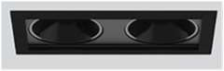 |  | Nos |  |  |  |  |  |  |  |  | Dimension: o 122 X65mm & H=115mm |  |  |  |  |  | Nos
 | Lamp:14.2W LED, 26°, Focusable, 3000K, CRI=93+(R9≥40+) |  |  |  |  |  |  |  |  |  |  |  |  |  |  |  |  |  | Lamp:14.2W LED, 26°, Focusable, 3000K, CRI=93+(R9≥40+)
 | Lumen Output : 1254lm |  |  |  |  |  |  |  |  |  |  |  |  |  |  |  |  |  | Lumen Output : 1254lm
 | Control Gear: Remote LED Driver. Dali Dimmable. |  |  |  |  |  |  |  |  |  |  |  |  |  |  |  |  |  | Control Gear: Remote LED Driver. Dali Dimmable.
 | Power Consumption: 14.2W/Unit |  |  |  |  |  |  |  |  |  |  |  |  |  |  |  |  |  | Power Consumption: 14.2W/Unit
 | IP20 |  |  |  |  |  |  |  |  |  |  |  |  |  |  |  |  |  | IP20
15 | Ceiling Recessed LED Down Light |  |  |  |  |  |  | ENDO Lighting |  |  |  |  |  |  |  |  |  | 15 | Ceiling Recessed LED Down Light |  |  |  |  |  |  |  |  |  | 11253 |  | 168795
 | Housing: Die cast aluminium |  |  |  |  | RDN4b |  | GERD8127WA-T |  | 15.00 |  | Black Trim Finish (In Bedroom 04 sloping ceiling) |  |  |  |  |  |  | Housing: Die cast aluminium ( Cust to Black Trim ) |  | RDN4b |  | GERD8127WA-T (CUSTOMISED TO BLACK TRIM) |  | 15.00 |  | Black Trim Finish (In Bedroom 04 sloping ceiling)  This is OK.
 | Dimension: ∅=108mm, Depth=100mm. |  |  |  |  |  |  | 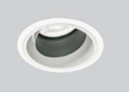 |  | Nos |  |  |  |  |  |  |  |  | Dimension: ∅=108mm, Depth=100mm. |  |  |  | 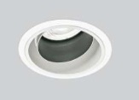 |  | Nos
 | Lamp: 19.8W LED,19°, Focusable ,3000K CRI=96+(R9≥40+) |  |  |  |  |  |  |  |  |  |  |  |  |  |  |  |  |  | Lamp: 19.8W LED,19°, Focusable ,3000K CRI=96+(R9≥40+)
 | Lumen Output : 1377lm |  |  |  |  |  |  |  |  |  |  |  |  |  |  |  |  |  | Lumen Output : 1377lm
 | Control Gear: Remote LED Driver. Dali Dimmable. |  |  |  |  |  |  |  |  |  |  |  |  |  |  |  |  |  | Control Gear: Remote LED Driver. Dali Dimmable.
 | Power Consumption: 19.8W |  |  |  |  |  |  |  |  |  |  |  |  |  |  |  |  |  | Power Consumption: 19.8W
 | IP20 |  |  |  |  |  |  |  |  |  |  |  |  |  |  |  |  |  | IP20
16 | Ceiling Recessed LED Down Light |  |  |  |  |  |  | ENDO Lighting |  |  |  |  |  |  |  |  |  | 16 | Ceiling Recessed LED Down Light |  |  |  |  |  |  |  |  |  | 11253 |  | 135036
 | Housing: Die cast aluminium |  |  |  |  | RDN4w |  | GERD8127WA-T |  | 12.00 |  | White Trim Finish (In Terrace Lobby sloping ceiling) |  |  |  |  |  |  | Ceiling Recessed LED Down Light |  | RDN4w |  | GERD8127WA-T |  | 12.00 |  | . NEW ITEM
 | Dimension: ∅=108mm, Depth=100mm. |  |  |  |  |  |  |  |  | Nos |  |  |  |  |  |  |  |  | Housing: Die cast aluminium |  |  |  |  |  | Nos
 | Lamp: 19.8W LED,19° , Focusable ,3000K CRI=96+(R9≥40+) |  |  |  |  |  |  |  |  |  |  |  |  |  |  |  |  |  | Dimension: ∅=108mm, Depth=100mm.
 | Lumen Output : 1377lm |  |  |  |  |  |  |  |  |  |  |  |  |  |  |  |  |  | Lamp: 19.8W LED,19°, Focusable ,3000K CRI=96+(R9≥40+)
 | Control Gear: Remote LED Driver. Dali Dimmable. |  |  |  |  |  |  |  |  |  |  |  |  |  |  |  |  |  | Lumen Output : 1377lm
 | Power Consumption: 19.8W |  |  |  |  |  |  |  |  |  |  |  |  |  |  |  |  |  | Control Gear: Remote LED Driver. Dali Dimmable.
 | IP20 |  |  |  |  |  |  |  |  |  |  |  |  |  |  |  |  |  | Power Consumption: 19.8W
 |  |  |  |  |  |  |  |  |  |  |  |  |  |  |  |  |  |  | IP20
17 | Ceiling Recessed LED Down Light |  |  |  |  |  |  | ENDO Lighting |  |  |  |  |  |  |  |  |  | 17 | Ceiling Recessed LED Down Light |  |  |  |  |  |  |  |  |  | 13401 |  | 67005
 | Housing: Die cast aluminium |  |  |  |  | RDN5 |  | GERD8202WB-T |  | 5.00 |  |  |  |  |  |  |  |  | Housing: Die cast aluminium |  | RDN5 |  | GERD8202WB-T |  | 5.00 |  | This is OK.
 | Dimension: ∅=108mm, Depth=133mm. |  |  |  |  |  |  |  |  | Nos |  |  |  |  |  |  |  |  | Dimension: ∅=108mm, Depth=133mm. |  |  |  |  |  | Nos
 | Lamp: 28.5W LED, 32°, Fixed Optics, 3000K CRI=83+(R9≥40+) |  |  |  |  |  |  |  |  |  |  |  |  |  |  |  |  |  | Lamp: 28.5W LED, 32°, Fixed Optics, 3000K CRI=83+(R9≥40+)
 | Lumen Output : 1597lm |  |  |  |  |  |  |  |  |  |  |  |  |  |  |  |  |  | Lumen Output : 1597lm
 | Control Gear: Remote LED Driver. Dali Dimmable. |  |  |  |  |  |  |  |  |  |  |  |  |  |  |  |  |  | Control Gear: Remote LED Driver. Dali Dimmable.
 | Power Consumption: 28.5W |  |  |  |  |  |  |  |  |  |  |  |  |  |  |  |  |  | Power Consumption: 28.5W
 | IP20 |  |  |  |  |  |  |  |  |  |  |  |  |  |  |  |  |  | IP20
18 | Surface Mounted LED Down Light. |  |  |  |  |  |  | ABBY Lighting |  |  |  |  |  |  |  |  |  | 18 | Surface Mounted LED Down Light. |  |  |  |  |  |  |  |  |  | 3908 |  | 54712
 | Housing: Die cast aluminium |  |  |  |  | SDN1 |  | iPlane round surface-15W |  | 14.00 |  |  |  |  |  |  |  |  | Housing: Die cast aluminium |  | SDN1 |  | Abby Surface Down light 14W, 3000K |  | 14.00 |  | OLD QTY 10 NOS. WE HAVE PROPOSED ALTERNATE ECONOMICAL OPTION IN Abby BRAND.
 | Dimension: ∅=152mm & H=38mm. |  |  |  |  |  |  | 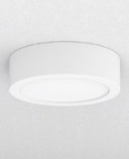 |  | Nos |  |  |  |  |  |  |  |  | Dimension: ∅=152mm & H=38mm. |  |  |  | 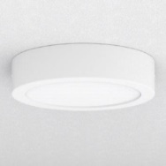 |  | Nos
 | Lamp: 15W LED, 116°, Fixed, 3000K, CRI=96+(R9≥40+) |  |  |  |  |  |  |  |  |  |  |  |  |  |  |  |  |  | Lamp:15W LED, Flood Beam, Fixed, 3000K, CRI=85+(R9≥40+)
 | Lumen Output : 1209lm |  |  |  |  |  |  |  |  |  |  |  |  |  |  |  |  |  | Lumen Output : 1209lm
 | Control Gear: Integral LED Driver. Dali Dimmable. |  |  |  |  |  |  |  |  |  |  |  |  |  |  |  |  |  | Control Gear: LED Driver. Dali Dimmable.
 | Power Consumption: 15W |  |  |  |  |  |  |  |  |  |  |  |  |  |  |  |  |  | Power Consumption: 15W
 | IP44 Required |  |  |  |  |  |  |  |  |  |  |  |  |  |  |  |  |  | IP44 Required
19 | Ceiling Recessed LED Light, Fixed. |  |  |  |  |  |  | ABBY Lighting |  |  |  |  |  |  |  |  |  | 19 | Ceiling Recessed LED Light, Fixed. |  | SDN2 |  | GERD8604W-T |  | 12.00 |  |  |  | 10345 |  | 124140
 | Housing: Spun Aluminium |  |  |  |  | SDN2 |  | SPA 63 - 22W |  | 12.00 |  |  |  |  |  |  |  |  | Housing: Die cast aluminium |  |  |  | 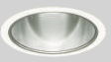 |  | Nos
 | Dimension: ∅=94mm, Cutout∅=84 & Height=104mm. |  |  |  |  |  |  | 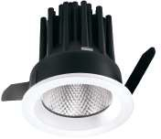 |  | Nos |  |  |  |  |  |  |  |  | Dimension: ∅=108mm, Cutout∅=100 & Height=110mm.
 | Lamp: 22W LED, 32° Fixed, 3000K, CRI=90+(R9≥40+) |  |  |  |  |  |  |  |  |  |  |  |  |  |  |  |  |  | Lamp:19.3W LED, 31° Fixed, 3000K, CRI=85(R9≥40+)
 | Lumen Output : 1704 lm |  |  |  |  |  |  |  |  |  |  |  |  |  |  |  |  |  | Lumen Output : 2014lm
 | Control Gear: Remote LED Driver. Dali Dimmable. |  |  |  |  |  |  |  |  |  |  |  |  |  |  |  |  |  | Control Gear: Remote LED Driver. Dali Dimmable.
 | Power Consumption: 22W |  |  |  |  |  |  |  |  |  |  |  |  |  |  |  |  |  | Power Consumption: 19.3W
 | minimum IP44 Required. |  |  |  |  |  |  |  |  |  |  |  |  |  |  |  |  |  | IP44 Required
20 | Spike Mounted LED Projector Light. |  |  |  |  |  |  | PUK Lighting |  |  |  |  |  |  |  |  |  | 20 | Spike Mounted LED Projector Light. |  |  |  | GERS6922H-T |  | 11.00 |  | OLD QTY 6 |  | 10819 |  | 119009
 | Housing: Hard Anodized Aluminium |  |  |  |  | SPK1 |  | 101903 |  | 11.00 |  |  |  |  |  |  |  |  | Housing: Alluminium |  | SPK1 |  |  |  | Nos
 | Accessories : Anti-glare snoot (AC098)& Spike (AC044) |  |  |  |  |  |  | 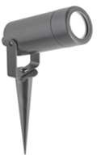 |  | Nos |  |  |  |  |  |  |  |  | Dimension: ∅=61mm, Ht=141mm |  | 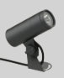
 | Dimension: ∅=50mm, Ht=90mm |  |  |  |  |  |  |  |  |  |  |  |  |  |  |  |  |  | Lamp:10W LED,23º, 3000K CRI=80+
 | Lamp: 10W LED,10º, 3000K CRI=80+ |  |  |  |  |  |  |  |  |  |  |  |  |  |  |  |  |  | Lumen Output : 758lm
 | Lumen Output : 489lm |  |  |  |  |  |  |  |  |  |  |  |  |  |  |  |  |  | Control Gear: Remote LED Driver. Non-Dimmable.
 | Control Gear: Remote LED Driver. Non-Dimmable. |  |  |  |  |  |  |  |  |  |  |  |  |  |  |  |  |  | Power Consumption: 10.1W
 | Power Consumption: 10W |  |  |  |  |  |  |  |  |  |  |  |  |  |  |  |  |  | IP65 |  |  |  |  |  |  |  | OLD QTY 6 |  | 7530 |  | 82830
21 | Spike Mounted LED Projector Light. |  |  |  |  |  |  | PUK Lighting |  |  |  |  |  |  |  |  |  | 21 | Spike Mounted LED Projector Light. |  |  |  | GERS7306H-T +GRB898N |  | 11.00
 | Housing: Hard Anodized Aluminium |  |  |  |  | SPK2 |  | 101901 |  | 11.00 |  |  |  |  |  |  |  |  | Housing: Alluminium |  | SPK2 |  | 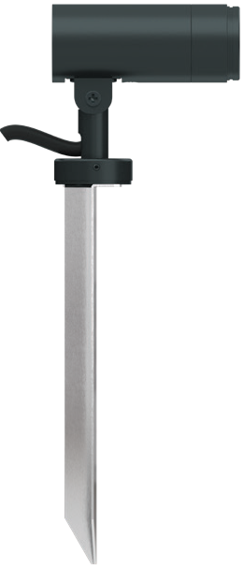  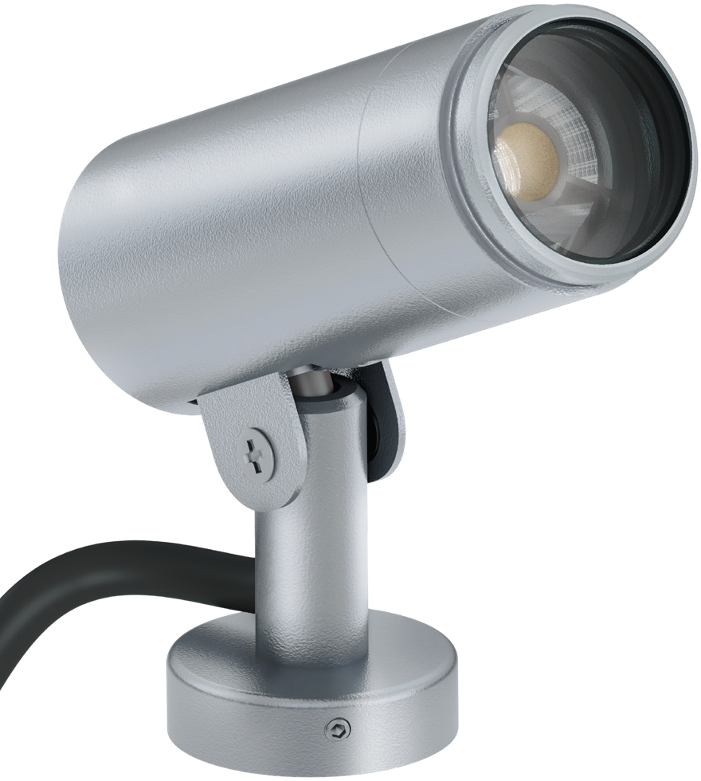 |  | nos
 | Accessory: Anti-glare snoot (AC098) & Ground Burried Spike (AC044) |  |  |  |  |  |  | 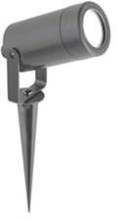 |  | Nos |  |  |  |  |  |  |  |  | Dimension: ∅=35mm, Ht=63mm
 | Dimension: ∅=35mm, Ht=63mm |  |  |  |  |  |  |  |  |  |  |  |  |  |  |  |  |  | Lamp:3W LED,45º, 3000K CRI=80+
 | Lamp: 3W LED, 45º, 3000K CRI=80+ |  |  |  |  |  |  |  |  |  |  |  |  |  |  |  |  |  | Lumen Output : 230lm
 | Lumen Output : 230lm |  |  |  |  |  |  |  |  |  |  |  |  |  |  |  |  |  | Control Gear: Remote LED Driver. Non-Dimmable.
 | Control Gear: Remote LED Driver. Non-Dimmable. |  |  |  |  |  |  |  |  |  |  |  |  |  |  |  |  |  | Power Consumption: 10.1W
 | Power Consumption: 3W |  |  |  |  |  |  |  |  |  |  |  |  |  |  |  |  |  | IP65
 | IP66
22 | Underwater LED Up Lighter. |  |  |  |  |  |  | PUK Lighting |  |  |  |  |  |  |  |  |  | 22 | Underwater LED Up Lighter.
 | Housing: Stainless Steel |  |  |  |  | UWL3 |  | 301004 |  | 2.00 |  | Black Finish Required |  |  |  |  |  |  | Housing: Stainless Steel |  | UWL3 |  |  |  |  |  | Regret
 | Dimension: TrimØ=81mm, Cut OutØ=79mm & Ht=100mm. |  |  |  |  |  |  | 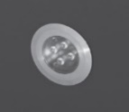 |  | Nos |  |  |  |  |  |  |  |  | Dimension: TrimØ=81mm, Cut OutØ=79mm & Ht=100mm.
 | Lamp: 6W LED, 10°, 3000K, CRI=80+ |  |  |  |  |  |  |  |  |  |  |  |  |  |  |  |  |  | Lamp: 6W LED, 10°, 3000K, CRI=80+
 | Lumen Output : 576lm |  |  |  |  |  |  |  |  |  |  |  |  |  |  |  |  |  | Lumen Output : 576lm
 | Control Gear: Remote LED Driver. Dali Dimmable. |  |  |  |  |  |  |  |  |  |  |  |  |  |  |  |  |  | Control Gear: Remote LED Driver. Dali Dimmable.
 | Power Consumption: 6W |  |  |  |  |  |  |  |  |  |  |  |  |  |  |  |  |  | Power Consumption: 6W
 | IP68 |  |  |  |  |  |  |  |  |  |  |  |  |  |  |  |  |  | IP68
23 | Wall Mounted LED Light. |  |  |  |  |  |  | PUK Lighting |  |  |  |  |  |  |  |  |  | 23 | Wall Mounted LED Light. |  |  |  | EWLR2-300-1030-K |  | 5.00 |  | OLD QTY 6 |  | 14811 |  | 74055
 | Housing: Die cast Aluminium |  |  |  |  | WML1 |  | 402403 |  | 5.00 |  |  |  |  |  |  |  |  | Housing: Die cast Aluminium |  | WML1 |  | 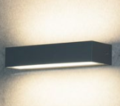 |  | Nos
 | Dimension: L=354mm, W=120mm & Ht=36mm. |  |  |  |  |  |  | 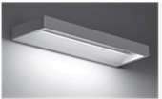 |  | Nos |  |  |  |  |  |  |  |  | Dimension: ∅=300mm, Ht=57mm
 | Lamp: 12W LED, 3000K, CRI=80+ |  |  |  |  |  |  |  |  |  |  |  |  |  |  |  |  |  | Lamp:9W LED,92°×75°, 3000K CRI=80+
 | Lumen Output : 574lm |  |  |  |  |  |  |  |  |  |  |  |  |  |  |  |  |  | Lumen Output : 836lm
 | Control Gear: Integral LED Driver. Dali Dimmable. |  |  |  |  |  |  |  |  |  |  |  |  |  |  |  |  |  | Control Gear: Remote LED Driver. Non-Dimmable.
 | Power Consumption: 12W |  |  |  |  |  |  |  |  |  |  |  |  |  |  |  |  |  | Power Consumption: 9W
 | IP65 |  |  |  |  |  |  |  |  |  |  |  |  |  |  |  |  |  | IP65
24 | Wall Recessed LED Light. |  |  |  |  |  |  | PUK Lighting |  |  |  |  |  |  |  |  |  | 24 | Wall Recessed LED Light. |  |  |  |  |  |  |  | OLD QTY 10 |  | 7378 |  | 81158
 | Housing: Die cast Aluminium |  |  |  |  | WRL1 |  | 502017 |  | 11.00 |  |  |  |  |  |  |  |  | Housing: Die cast Aluminium |  | WRL1 |  | ELFR5-255-0630-K |  | 11.00
 | Dimension: Trim Size=255 X 76mm, Depth= 81mm |  |  |  |  |  |  |  |  | Nos |  |  |  |  |  |  |  |  | Dimension: ∅=255mm, Ht=67mm |  |  |  |  |  | Nos
 | Lamp: 7W LED, 120°, 3000K, CRI=80+ |  |  |  |  |  |  |  |  |  |  |  |  |  |  |  |  |  | Lamp: 5.7W LED, 3000K CRI=80+
 | Lumen Output : 180lm |  |  |  |  | 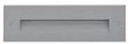 |  |  |  |  |  |  |  |  |  |  |  |  | Lumen Output : CW=113 WW=104 |  | 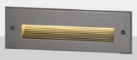
 | Control Gear: Integral LED Driver. Non- Dimmable. |  |  |  |  |  |  |  |  |  |  |  |  |  |  |  |  |  | Control Gear: Remote LED Driver. Non-Dimmable.
 | Power Consumption: 7W |  |  |  |  |  |  |  |  |  |  |  |  |  |  |  |  |  | Power Consumption: 5.7W
 | IP65 |  |  |  |  |  |  |  |  |  |  |  |  |  |  |  |  |  | IP65
25 | Wall Recessed LED FootLight. |  |  |  |  |  |  | PUK Lighting |  |  |  |  |  |  |  |  |  | 25 | Wall Recessed LED FootLight |  | WRL2 |  | ELFR2-72-0330-K |  | 21.00 |  |  |  | 5590 |  | 117390
 | Housing: Stainless Steel |  |  |  |  | WRL2 |  | 502015 |  | 21.00 |  |  |  |  |  |  |  |  | Housing: Die cast Aluminium |  |  |  |  |  | Nos
 | Dimension: Trim Size=79 X 79mm, Depth= 77mm |  |  |  |  |  |  | 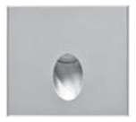 |  | Nos |  |  |  |  |  |  |  |  | Dimension: ∅=72mm, Ht=75mm |  |  |  | 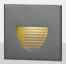
 | Lamp: 1W LED, 3000K, CRI=80+ |  |  |  |  |  |  |  |  |  |  |  |  |  |  |  |  |  | Lamp: 3.1W LED, 3000K CRI=80+
 | Lumen Output : 60lm |  |  |  |  |  |  |  |  |  |  |  |  |  |  |  |  |  | Lumen Output : CW=25 WW=22
 | Control Gear: Integral LED Driver. Non- Dimmable. |  |  |  |  |  |  |  |  |  |  |  |  |  |  |  |  |  | Control Gear: Remote LED Driver. Non-Dimmable.
 | Power Consumption: 1W |  |  |  |  |  |  |  |  |  |  |  |  |  |  |  |  |  | Power Consumption: 3.1W
 | IP65 |  |  |  |  |  |  |  |  |  |  |  |  |  |  |  |  |  | IP65
 |  |  |  |  |  |  |  |  |  |  |  |  |  |  |  |  |  | 26 | Wall Recessed LED Light. |  | WRL3 |  | ELFR5-255-0630-K |  | 6.00 |  | NEW ITEM |  | 7378 |  | 44268
26 | Wall Recessed LED Light (To be Customize to 4W). |  |  |  |  |  |  | PUK Lighting |  |  |  |  |  |  |  |  |  |  | Housing: Die cast Aluminium |  |  |  |  |  | Nos
 | Housing: Die cast Aluminium |  |  |  |  | WRL3 |  | 502017 |  | 6.00 |  |  |  |  |  |  |  |  | Dimension: ∅=255mm, Ht=67mm |  |  |  | 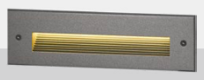
 | Dimension: Trim Size=255 X 76mm, Depth= 81mm |  |  |  |  |  |  |  |  | Nos |  |  |  |  |  |  |  |  | Lamp: 5.7W LED, 3000K CRI=80+
 | Lamp: 4W LED, 120°, 3000K, CRI=80+ |  |  |  |  |  |  |  |  |  |  |  |  |  |  |  |  |  | Lumen Output : CW=113 WW=104
 | Lumen Output : 100lm |  |  |  |  |  |  |  |  |  |  |  |  |  |  |  |  |  | Control Gear: Remote LED Driver. Non-Dimmable.
 | Control Gear: Integral LED Driver. Non- Dimmable. |  |  |  |  |  |  |  |  |  |  |  |  |  |  |  |  |  | Power Consumption: 5.7W
 | Power Consumption: 4W |  |  |  |  |  |  |  |  |  |  |  |  |  |  |  |  |  | IP65
 | IP65
 |  |  |  |  |  |  |  |  |  |  |  |  |  |  |  |  |  |  |  |  |  |  |  |  |  |  |  |  |  | Total |  | 4,000,000
 |  |  |  |  |  |  |  |  |  |  |  |  |  |  |  |  |  |  |  |  |  |  |  |  |  |  |  |  |  | GST 18% |  | 720,000
 |  |  |  |  |  |  |  |  |  |  |  |  |  |  |  |  |  |  |  |  |  |  |  |  |  |  |  |  |  | Grand Total |  | 4,720,000

Underwater:

Client scope:
Scaffolding wherever required to be provided.
Electrification wherever necessary to be provided.
Fabrication like poles etc. to be provided.
Fabricated poles if required to be provided.
Civil work if required.

Payment Terms
100% Advance

Company’s Bank Details
Bank Name: Central Bank of India
Account Number: 3167002097
Branch & IFS Code: Panaji & CBIN0280713

Terms & conditions apply.
Quotation valid for 10 days only.
If payment not received on time interest @ 15% will be levied per annum.
Any extra item if required to be charged as actual.
Warranty as per manufacturer not valid in case of surges, fluctuation, lightening etc.to be claimed directly with the
manufacturer without involving JP TECHATRONICS.
Solution done as per recommendation and request by client hence, JP TECHATRONICS or its employees should not be held responsible for any kind of malfunctioning of the system for any reasons.
Services like data backup, searching footage, port forwarding etc. to be charged as actuals.
Service calls post installation to be charged as actuals.

